Osbourn Park High School Summer Assignment AP Physics 1

AP Physics 1 Name: ____________________________________ Summer Assignment

Dear student,

Welcome to AP Physics 1 at Osbourn Park High School. This is a first (or second) year physics course that covers the equivalent of two semesters of college level physics. Due to the large amount of material in the AP Physics 1 curriculum and the short amount of time we have to cover that material, this course moves at a very fast pace. This level of academic rigor is likely more than you have experienced in your past studies, but in the end, you will not only be prepared to take the AP exam, but you will also be ready for the style of academic study found within most college programs.

Physics, and AP Physics 1, requires an exceptional proficiency in algebra, trigonometry, and geometry. In addition to the science concepts, Physics often seems like a course in applied mathematics. The following assignment includes mathematical problems that are considered routine in AP Physics 1. This includes knowing several key metric system conversion factors and how to employ them, graphical analysis of data, and understanding vectors.

The attached pages contain carefully crafted review, hints, and example problems. It is hoped that combined with your previous math knowledge, this assignment is a review and a starting point in your study of physics.

Required Materials​: Calculator, pencil, ruler (for 1 problem)

Due Date​: First day of school

Expected time for completion​: a few hours

Additional Resources​: the Internet

Teacher Contact Information​: Mr. Goozh – goozhid@pwcs.edu

Purpose of assignment: This assignment serves as the beginning of our rigorous course of study in AP Physics 1. The primary goal of this assignment is to serve as a math review that will help you brush up on the mathematical concepts utilized throughout the course.

Skills/Knowledge required for completion: Algebra and Geometry math skills; Mathematical fundamentals of chemistry and/or general physics; Ability to follow instructions

Grading: This will be submitted on Day 1 and is worth 25 points in the class.

Please read the text and instructions throughout.

***There will be a quiz covering this packet toward the end of the first week of class.

Show work in order to receive as much credit as possible on all problems. The more work you show, the more points I can award if you make a mistake or arrive at an incorrect answer.

What if I don’t get all the problems or don’t understand the instructions?
Seek help! Find Physics and Math Tutorials on the web by visiting https://osbournparkhs.pwcs.edu/class_pages/science/ian_goozh/useful_links/
or searching for specific topics on your own.

Section One: Working with Equations
Problems in Physics are first done using variables only. Only after solving for the desired variable should values be substituted into the equations. The following problems require you to solve for specific variables. Don’t let the different letters confuse you.

- v² = v_{o}² + 2a(x − x_{o}) a =__________________

- PE = ½ kx² x =__________________

- T_{p} = 2π√(L/g) g =__________________

- F_{g} = Gm₁m₂/r² r =__________________

- mgh = ½ mv² v =__________________

- pV = nRT T = __________________

- sin θ_{c} = n₁/n₂ θ = __________________

- qV = 1/2 mv² v =__________________

- 1/f = 1/d₀ + 1/d_{i} d_{i} =

- 1/R_{P} = 1/R₁ + 1/R₂ + 1/R₃ R₂ = _________________

- P = IV and I = V/R Create two other equations for P

- If F_{g} = GMm/r² and F_{g} = mg, create a new equation for F_{g} in terms of G, M, and r

Section Two: Working with Calculations / Scientific Notation​

The following are ordinary physics problems. Place the answer in scientific notation when appropriate and simplify the units. Always include correct sig figs. Scientific notation is used when it takes less time to write than the ordinary number does. As an example, 200 is easier to write than 2.00 x 10²​​, but 2.00 x 10⁸​​ is easier to write than 200,000,000. They can also have different numbers of sig figs. Do your best to cancel units, and attempt to show the simplified units in the final answer. Maintain the proper number of sig figs in your answer as well. Remember that constants (numbers without units) have unlimited/infinite sig figs.

- q = (1.50 x 10⁶ e⁻)(1.60 x 10⁻¹⁹ C/e⁻) q = _________________

- F_{net} = 2.75 x 10³ N + 8.4 x 10² N + 5.71 x 10⁴ N F_{net} =

- 8,890 m/s = √((6.673 x 10⁻¹¹ Nm²/kg²)(7.35 x 10²⁶ kg) / r²) r =

- t = √(2(-50.0 m) / (-9.81 m/s²)) t =

- 2.70 g/cm³ = (9.276 g) / V V =

- KE = ½ (6.6 x 10² kg)(2.11 x 10⁴ m/s)² KE = ______________

- F = (8.99 x 10⁹ Nm²/C²)(3.2 x 10⁻⁹ C)(9.6 x 10⁻⁹ C) / (0.32 m)² F =

- 1.33 sin 25⁰ = 1.50 sin θ θ =___________________

Section Three: Measurements
When using a measuring device, you MUST estimate one digit between the smallest marks on the instrument. For example, if a ruler is marked off in increments of whole numbers, you estimate the length of an object to the closest tenth of a millimeter.

21. Use the ruler below to measure the length of the arrow. Remember to estimate between the smallest marks.
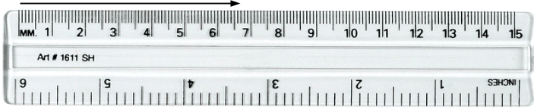

The length of the arrow is ____ _ mm.

Section Four: Units and Conversions

Science uses the MKS system based on SI (SI ­ Systeme Internationale ­ the metric system). MKS stands for meters, kilograms, seconds. These are the basic units of physics. The equations in physics depend on unit agreement. Therefore, you must convert to MKS in most problems to arrive at the correct answer.

There are two categories of conversions: (1) converting with SI prefixes and (2) converting to different scales.

(1)
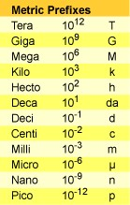
kilometers (km) to meters (m) and meters to kilometers
centimeters (cm) to meters (m) and meters to centimeters
milliseconds (ms) to seconds(s) and seconds to milliseconds
nanometers (nm) to meters(m) and meters to nanometers
gram (g) to kilogram (kg) and kilogram to gram

(2)
Celsius (℃) to Kelvin (K)
atmospheres (atm) to Pascals (Pa)
Liters (L) to cubic meters (m³​​)
miles to km

- One Simple Method for Converting SI Prefixes:
Where you see the prefix, simply replace with the exponential notation. If you are converting from one prefix to another, subtract the powers of 10 represented by the prefixes. The result of the subtraction is the new power of 10.

Example 1: 600 nm = ? m
From above chart: nano = 10^{­9} and meter has no prefix (10⁰)​ -9 – 0 = -9
600 nm = 600 x 10⁻⁹ 6 x 10⁻⁷ m

Example 2: 27 ML = dL
From the above chart: Mega = 10⁶ and deci = 10⁻¹ 6 – (-1) = 7
27 ML = 27 x 10⁷ dL 2.7 x 10⁸ dL

- Dimensional Analysis or Factor Label Method for Converting Units (​preferred!​):

Example 3: 150 yards to inches
150 yd x 3 ft x 12 in = 5,400 in
1 yd 1 ft

Example 4: 350 cm = ? km
350 cm x 1 m x 1 km = 0.0035 km or 3.5 x 10⁻³ km
100 cm 1000 m

What if you don’t know the conversion factors? Colleges (and employers) want students who can find their own information. The internet can help, but remember, you MUST SHOW WORK to earn credit

22. 4008 g | = | _______________ kg
23. 2.1 km | = | _______________ m
24. 823 nm | = | _______________ m
25. 298 K | = | _______________ ℃
26 0.77 Gm | = | _______________ dm
27. 8.8 x 10⁶​ m | = | _______________ mm
28. 25.0 μm | = | _______________ cm
29. 3.67 x 10⁵ mm | = | _______________ inches

30. 728 days = s

31. 55 miles/hr = m/s

32. 49 in² = ft²

33. 384 cm³ = m³

Consider the following statements…

- Would you like to mow my lawn? I’m gonna pay you 10!
- My baby cousin only weighs 11.
- This morning I ran 4.
- I slept for 7 last night.
- My car has a top speed of 225.

Questions:
- Why are the above statements peculiar and poorly defined?

- What important piece of information needs to be added to the above statements for them to make physical sense?

Rewrite each statement with added information.

1)

2)

3)

4)

5)

STORY ONE: Circus Routines – Fill in the “libs” (blanks) with appropriate words (units). Since this is Physics, be sure to use METRIC/SI units!

My friend Johnny is thinking of joining the circus. He can do some awesome things. First of all, Johnny can lift
800 _________right over his head and can run at a top speed of 30 _________ for a time of 4 _________!
Just last week he threw a 70 _________ rock right over a 1200_________wall and was awarded 7500 _________ for that amazing feat. Johnny is 2 ____ tall and weighs an unworldly 310 _________. To keep up his physique he must eat 4 _________ of chicken and 6 _________ of beef every _________ and exercise with 20 _________weights for 12 _________. Johnny is hopeful that his impressive skills and routine will earn him the job of his dreams.

Consider the following statements…
- An employee at Target earns dollars per​​ hour ($/hr). ​(note the word “per” always means “divided by”)
- An average person has a mass of kg and a weight of newtons.
- I use my cellphone outside of class, for seconds in a month.
- The height from floor to ceiling in this classroom is meters
- The speed limit on a Canadian highway is km per hour (km/hr)

Questions:
- Why are the above statements incomplete?

- What important piece of information needs to be added to the above statements for them to make physical sense?

Rewrite each statement with added information.
1)

2)

3)

4)

5)

STORY TWO: The Northeastern Turkle – Fill in the “libs” (blanks) with appropriate sensible values.

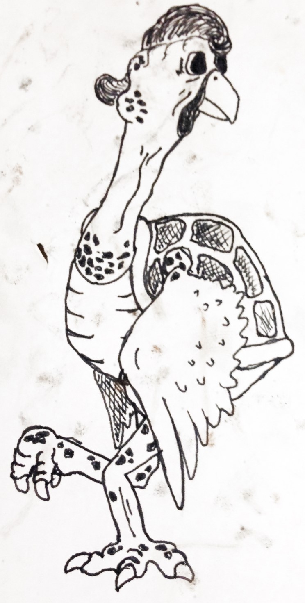
It is well known that the Northeastern Turkle (Turtle body with Turkey neck and head) will run at a top speed of _________ centimeters/hour and has a mass of _________kilograms. The unique shelled wings of the Turkle give it the surprising ability to fly at an altitude of _________ meters. The amazingly acute vision of the turtle means that it can see objects that are as small as _________ mm tall by _________ mm wide at a distance of _________ meters away. Unfortunately it doesn’t have terrific sense of hearing, and is only able to detect the sound of other yelping Turkles at the relatively close distance of _________meters way. The mature Turkle is an incredibly powerful creature and can use its talons to lift a person riding a bicycle weighing up to _________ newtons. While most Turkles are nocturnal in their natural Northeastern Habitat, they can fly _________ hours without resting during migration cycles to Lima, Peru. The favorite meal of the Turkle is bacon wrapped starfish which is slow cooked at a temperature of _________ °C for ________ hours.

Section Five: Geometry Review

Solve the following geometric problems.

- Line B touches the circle at a single point. Line A extends through the center of the circle.
  - VOCAB: What is the line B in reference to the circle?
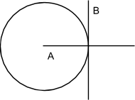
_______________
  - VOCAB: What is A in reference to the circle?

_______________
  - How large is the angle between A and B?

_______________

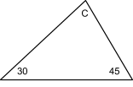
- What is angle C?

_______________

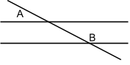
36. If Angle A is 30°, what is angle B?

_______________

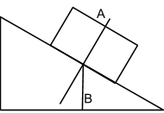
- If Line A is perpendicular to the ramp, and Line B is perpendicular to the bottom of the ramp, and the incline of the ramp is 30°, what is the angle between Lines A and B?

_______________

- The radius of a circle is 5.5 cm.
  - What is its circumference in meters?

_______________
  - What is its area in square meters?

_______________

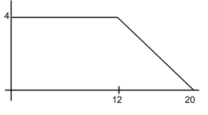
- What is the area of the space enclosed between the plotted line on the graph and the x and y axes at the right?

_______________

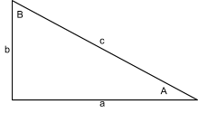
Using the generic triangle to the right, Right Triangle Trigonometry and the Pythagorean Theorem, solve the following. (​Your calculator must be in degree mode!)
- If A = 55° and c = 32 m, find sides a and b and angle B

- If A = 45° and a = 15 m/s, find sides b and c and angle B

- If a = 3 N, and b = 6.5 N, find angle A and B and side c

- If c = 40 m, and b=35m, find angle A and B and side c

Section Six: Graphical Analysis

Time (s) | Distance (m) | You should be familiar with graph construction (both by hand on graph paper and on a computer). Graphing is a topic that often appears on AP
0.0 | 0 | exams and will be required in many labs.  Note: When you are told to graph Apples vs. Oranges, the 1st thing goes on the y­axis, the second thing on the x­axis.  Using the following table, plot the points on the grid below as distance vs. time. Be sure to correctly label the graph (axis labels, units and title).
1.0 | 5.1
2.0 | 9.9
3.0 | 15.2
4.0 | 25.2
Now, create a line of best fit. This does not mean to connect the dots. If you do not know how to draw a line of best fit, think about where you could learn more about that.

- What is the slope of the line you created? SHOW ALL WORK _______________

- What are the units of your line? Knowing that, what does your slope represent?

Section Seven: Problem Solving Methodology

In Physics, problems can become complicated very quickly. Therefore, we utilize a Problem Solving Methodology to give us a step­by­step process to solve problems. You will use this process for solving all problems during the year. There are ten steps to this process. They are:
- Read the problem.​
- Create a meaningful Diagram if helpful.
- List all Variables​ or Givens and their associated ​Values​ (with units)​.​
- Convert any units to the base units (MKS).​
- Select the appropriate Formula(s)​ or Equation(s).
- Substitute values for variables (with units).​
- Rearrange the formula to solve for the appropriate variable.​
- Solve for the proper answer (with units).​
- Adjust your answer to have the appropriate number of Significant Figures​.​
- Circle your final answer (with units).​

For example: Susie rides her bike for 60.0 km in 3.00 hours. What was her average speed?
Step 1: Read the problem. (Done. Good job!)
Step 2: Create a meaningful diagram (probably not really necessary for this problem):

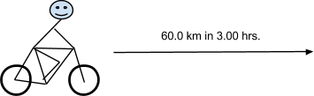

Step 3: List all values and associated variables: x = 60.0 km, t = 3.00 hr

Step 4: Convert any units to the base units (MKS).
60.0 km × 1,000 m = 6.00 × 10⁴ m
1 km
3.00 hr x 60 min x 60 s = 1.08 × 10⁴ s
1 hr 1 min
Step 5: Select the appropriate formula(s). x = vt
Step 6: Rearrange the formula to solve for the appropriate variable. v = x/t
Step 7: Substitute values for variables.
v = (6.00 x 10⁴) / (1.08 x 10⁴)
Step 8: Solve for the proper answer.
v = 5.55555555555555556 m/s
Step 9: Adjust your answer to have the appropriate number of significant figures. v = 5.56 m/s
Step 10: Circle your final answer.

Using the Problem Solving Methodology, solve the following problems.

- Pete walks at a rate of 4.0 m/s for 30.0 minutes in the same direction. How far did he walk?

- What is your weight on Mercury? The formula you will need is F_{g} = Gm_{p}m_{you}/r² , where G = 6.67 × 10⁻¹¹ Nm²/kg²,
m_{p} is the mass of Mercury in kg (look it up!), r_{p} is the radius of Mercury in m (look that up too!), and m_{you} is your
mass in kg (not weight).

- A cylinder with a radius of 8.0 cm is held at a constant temperature of 293 K and pressure of 2.0 × 10⁵ Pa. If there are 0.53 moles of gas and the relationship between the variables is PV=nRT where R = 8.31 J/(mole K). Find the height of the cylinder in m.

- Susie pulls a 23.2 kg box to the right with a force of 53.2 N, and Joey pulls the same box to the left with a force of 30.5 N. What is the total force on the box from Susie and Joey (magnitude and direction)? Since Isaac Newton discovered that F = ma, what is the acceleration of the box (magnitude and direction)?

- A standard Blu­Ray player consumes 96 W of power and a flat screen TV consumes 131 W. For simplicity sake, let’s say you watch one 2-hour movie every day for a year, during which time your electrical company charges $0.12 / kWhr (kilowatt hour) for the energy used. If energy is calculated by E = Pt, how much does the electricity for your movie habit cost in one year?

